Requesting Batch 1:

Could not do a full factorial (2^7 = 128) because batch is limited to 70 runs

Therefore did a 2^k-p fractional factorial design – requested a 2^6 = 64 run batch

What are the aliases?

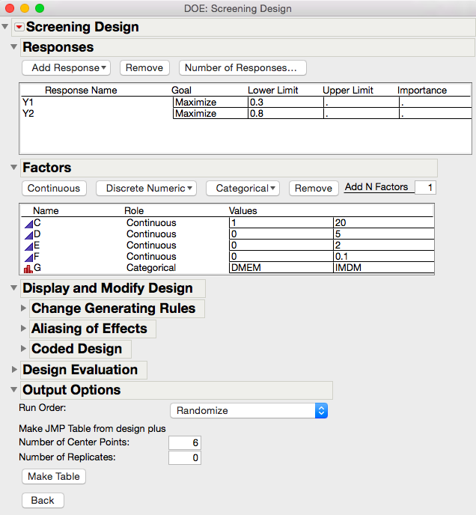

Analyze data Batch 1 – Fit Model

exclude centre points -> fit model for 3 interactions

Use diagnostic tests – anova and t test

Ensure assumptions are satisfied

Find proper method to analyze data satisfying the assumptions and do all the proper tests

Then request data

Evaluate design – colour map on correlation

For ccd determination: what is the best alpha? Use the colour map on correlation

* Can use for example alpha = 1.8 - > set -1 = -1.8 and 1 = 1.8 and recode the values

ANOVA Assumptions = normally distributed residuals, observations are independent, variance is the same for all groups

Y1 Fit Model

Removed centre points

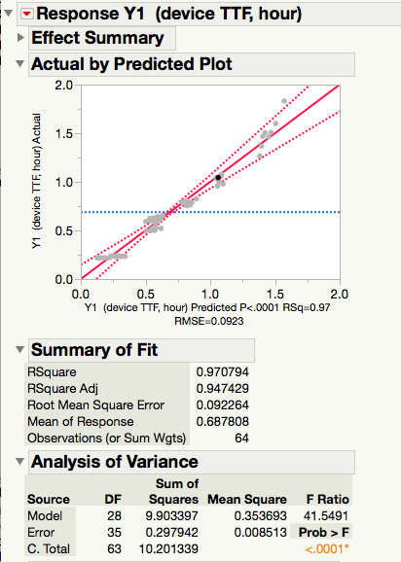

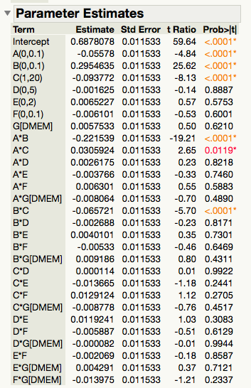

Therefore, A, B, C are significant factors and AB, AC, BC are the significant interactions

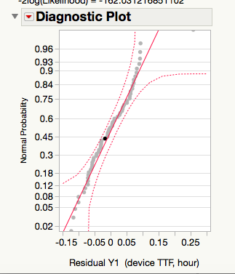

therefore residuals are normally distributed – satisfying ANOVA assumption

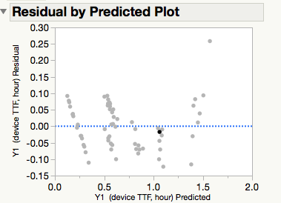

Y1 analysis with significant factors (ABC):

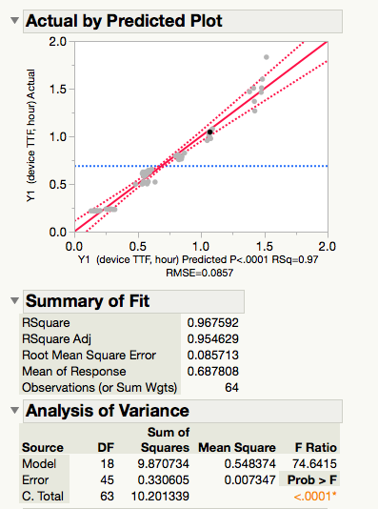

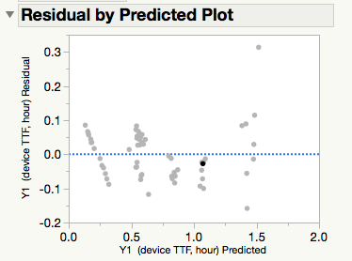

colour map on correlation for significant factors:

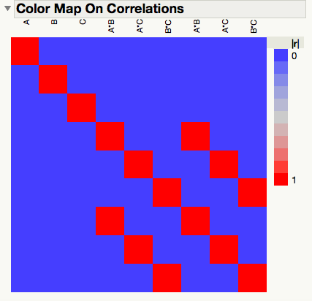

no correlation between factors

ccd: alpha = (2^k)^0.25 = 2, 6 centre points, CCD rotatable, inscribed